# MegaGlobalCorpSuperInc

Project Management in Practice

Alan Casey 0721662

JUN HE 0586374

Eoin Murphy 9021221

Yerenca Fernández 11037199

David O Neill 0813001

Friday 18th November 2011

Table of Contents

MegaGlobalCorpSuperInc 1

Project charter 4

Introduction 4

Charter 4

Project Work Breakdown Structure 6

Introduction 6

Work Breakdown Structure 6

Scope verification plan 8

Introduction 8

Roles and Responsibilities 8

Scope Definition 9

Scope Statement 9

Deliverables 9

Scope Verification 10

Scope Control 10

Sponsor Acceptance 10

Schedule 11

Introduction 11

Schedule 11

The project cash flow or budget 16

Introduction 16

Budget 17

Risk Log 21

Introduction 21

Risk Monitoring 21

Risk mitigation and avoidance 21

Qualitative and quantitative 21

Communications Plan 24

Introduction 24

Aims 24

Target Audience 24

Communications plan 25

Quality Plan 28

Introduction 28

Quality Plan 28

Purpose 28

Scope 28

Quality Objectives 28

Management Organization 29

Tasks and Responsibilities 30

Metrics 30

Project report 33

Analysis and critique 34

# Project charter

## Introduction

A project charter is a document that formally recognises the existence of a project and provides direction on the project’s objectives and management. It authorises the project manager to use organisational resources to complete the project. Key project stakeholder’s should sign a project charter to acknowledge agreement on the need for and the intent of the project.

## Charter

**Project Title:** Opening a new MegaGlobalCorpSuperInc branch in Ireland.

**Date of Authorization:** October 1

**Project Start Date:** October 1 **Project Finish Date:** October 1 2013

**Key Milestones:**

* Office fully operational with 50 developers by April 1 2012
* First version of software released by October 1 2012
* Scale up operations to 200 developers after October 1 2013

**Budget Information:**

The company has allocated €5 million for this project based on early budget estimates and more funds are available if necessary.

**Project Manager:** Yerenca Fernandez

**Project Objectives:**

Our new Irish branch will be a software development house for MegaGlobalCorpSuperInc internal IT needs. It is a crucial project for our company to continue to grow in a competitive market. This is the first charter for the project and the objectives are to have the branch fully operational with 50 developers in 6 months, to release the first version of software to our internal customer by the end of year 1 and to scale up to 200 developers by the end of year 2.

**Main Project Success Criteria:**

The branch must be fully operational with 200 developers by October 1 2013. The software must meet all specified criteria, be thoroughly tested and have its first major release within 12 months.

**Approach:**

* Hold weekly progress review meetings with all the core project team.
* Within one month develop a clear work breakdown structure, scope verification plan and project schedule.
* Picking and setting up of Office, server and network hardware within 2 months.
* Purchase all required hardware within 3 months
* New Employee Orientation to be completed for initial employees and 50 developers by month 6
* Conduct thorough software testing per approved test plans

**Roles and Responsibilities:**

|  |  |  |  |
| --- | --- | --- | --- |
| Name | Role | Position | Contact Information |
| Vispi Shroff | Sponsor | CEO | Vispi.Shroff@lero.ie |
| Yerenca Fernandez | Team Member | Project Manager | dmz.oneill@gmail.com |
| Alan Casey | Team Member | Team Lead | alancasey20@gmail.com |
| David O'Neill | Team Member | Team Member | yerenka@gmail.com |
| Jun He | Team Member | Team Member | ilovefjjq@gmail.com |
| Eoin Murphy | Team Member | Team Member |  |

**Sign Off:**

**Comments:**

# Project Work Breakdown Structure

## Introduction

A work breakdown structure (WBS) is a deliverable-oriented grouping of the work involved in a project that defines the total scope of the project. Because most projects involve many people and many different deliverables, it is important to organise and divide the work into logical parts based on how the work will be performed. The WBS is a foundation document in project management because it provides the basis for planning and managing project schedules, costs, resources and changes.

## Work Breakdown Structure

|  |  |  |
| --- | --- | --- |
| Level 1 | Level 2 | Level 3 |
| 1. Opening a new branch of MegaGlobalCorpSuperInc | 1.1 Initiation and Planning | 1.1.1. Develop a Project Charter |
|  |  | 1.1.2. Submit Project Charter |
|  |  | 1.1.3. Develop Project Plan |
|  |  | 1.1.4. Submit Project Plan |
|  |  | 1.1.5. Milestone Project Plan approved |
|  | 1.2 Site Preparation | 1.2.1 Evaluation and Choosing of an office |
|  |  | 1.2.2 Acquisition of Office furnishings |
|  |  | 1.2.3 Gather Hardware Requirements |
|  |  | 1.2.4 Acquisition of Necessary Hardware |
|  | 1.3 Hiring of Staff | 1.3.1 Create List of Potential Employees |
|  |  | 1.3.2 Interviewing of Potential Employees |
|  |  | 1.3.3 30 developers by month 4 |
|  |  | 1.3.4 New Employee Orientation for initial developers |
|  |  | 1.3.5 40 developers by month 5 |
|  |  | 1.3.6. New Employee Orientation for additional developers |
|  |  | 1.3.7. Milestone: 50 developers by month 6 |
|  |  | 1.3.8. New Employee Orientation for additional developers |
|  |  | 1.3.9. Milestone: 200 developers by month 24 |
|  | 1.4 Software Development | 1.4.1. Gather Requirements |
|  |  | 1.4.2. Requirements Analysis |
|  |  | 1.4.3. System Design |
|  |  | 1.4.4. System Implementation |
|  |  | 1.4.5. System Testing |
|  |  | 1.4.6. System Deployment |
|  |  | 1.4.7. System Maintenance |

# Scope verification plan

## Introduction

It is especially difficult on information technology projects to verify the project scope and minimise changes. Even when the project scope is fairly well defined, many information technology projects suffer from scope creep – the tendency for project scope to keep getting bigger and bigger. It is very important to verify the project scope with users throughout the life of the project and develop a process for controlling scope changes. Scope verification involves formal acceptance of the completed project scope by the stakeholders. This acceptance is often achieved by a customer inspection and then sign-off on key deliverables.

## Roles and Responsibilities

The Project Manager, Sponsor and team will all play key roles in managing the scope of this project. As such, the project sponsor, manager, and team members must be aware of their responsibilities in order to ensure that work performed on the project is within the established scope throughout the entire duration of the project. The table below defines the roles and responsibilities for the scope management of this project.

|  |  |  |
| --- | --- | --- |
| Name | Role | Responsibilites |
| Vispi Shroff | Sponsor | Measure and verify project scope  Approve or deny scope change requests as appropriate  Accept project deliverables  Evaluate need for scope change requests |
| David O’Neill | Team Member | Facilitate scope change requests  Facilitate impact assessments of scope change requests  Organize and facilitate scheduled change control meetings  Communicate outcomes of scope change requests  Update project documents upon approval of all scope changes |
| Alan Casey | Team Lead | Validate scope change requests  Participate in impact assessments of scope change requests  Communicate outcomes of scope change requests to team  Facilitate team level change review process |
| Yerenca Fernandez | Project Manager | Participate in defining change resolutions  Evaluate the need for scope changes and communicate them to the project manager as necessary |
| Jun He | Team Member | Participate in defining change resolution  Evaluate the need for scope changes and communicate them to the project manager as necessary |
| Eoin Murphy | Team Member | Participate in defining change resolution  Evaluate the need for scope changes and communicate them to the project manager as necessary |

## Scope Definition

### Scope Statement

This project includes the creation of a software development house in the Republic of Ireland for MegaGlobalCorpSuperInc's internal IT needs. The deliverables for this project are to have the office fully operational with 50 developers by Month 6, with a plan to scale up to 200 developers by Year 2, first major release of the software to be produced for internal customers by the the end of Year 1. This project will be accepted once the software has been successfully tested in each department and has been shown to be compatible with the company’s current information technology (IT) infrastructure and the Project Sponsor and Project Manager formally accepts the current capabilities of the office match that in the project deliverables. Additionally the project is not to exceed 24 months and a initial budget of €5 million has been allocated. Assumptions for this project are that support will be provided by the project sponsor and parent company and that adequate resources are available for the successful completion of the project.

### Deliverables

* Formal acceptance of project charter by 1st October 2011
* Formal acceptance of Scope Verification Plan by 1st October 2011
* Formal acceptance of the Project Plan by 1st October 2011
* Premises selected and approved by 1st November 2011
* Office fully operational with 50 developers by April 1 2012
* First version of software released by October 1 2012
* Scale up operations to 200 developers after October 1 2013

### Scope Verification

As this project progresses the Project Manager will verify interim project deliverables against the original scope as defined in the scope statement, WBS and WBS Dictionary. Once the Project Manager verifies that the scope meets the requirements defined in the project plan, the Project Manager and Sponsor will meet for formal acceptance of the deliverable. During this meeting the Project Manager will present the deliverable to the Project Sponsor for formal acceptance. The Project Sponsor will accept the deliverable by signing a project deliverable acceptance document. This will ensure that project work remains within the scope of the project on a consistent basis throughout the life of the project.

### Scope Control

The Project Manager and the project team will work together to control of the scope of the project. The project team will leverage the WBS Dictionary by using it as a statement of work for each WBS element. The project team will ensure that they perform only the work described in the WBS dictionary and generate the defined deliverables for each WBS element. The Project Manager will oversee the project team and the progression of the project to ensure that this scope control process if followed.

If a change to the project scope is needed the process for recommending changes to the scope of the project must be carried out. All change requests must be submitted to the Project Manager in the form of a project change request document. The Project Manager will then review the suggested change to the scope of the project. The Project Manager will then either deny the change request if it does not apply to the intent of the project or convene a change control meeting between the project

team and Sponsor to review the change request further and perform an impact assessment of the change. If the change request receives initial approval by the Project Manager and Sponsor, the Project Manager will then formally submit the change request to the Change Control Board. If the Change Control Board approves the scope change the Project Sponsor will then formally accept the change by signing the project change control document. Upon acceptance of the scope change by the Change Control Board and Project Sponsor the Project Manager will update all project documents and communicate the scope change to all project team members

stakeholders.

### Sponsor Acceptance

Approved by the Project Sponsor:

<Project Sponsor>

Date:

# Schedule

## Introduction

Schedule development uses project time management processes to determine the start and end dates of the project. The ultimate goal goal of developing the schedule is to create a realistic project schedule that provides a basis for monitoring project progress for the time dimension of the project. The main outputs of this process ate the project schedule, a schedule baseline, project document updates and schedule data. Several tools and techniques assist in schedule development. The critical path method predicts total project duration. The critical path for a project is the series of activities that determines the earliest completion date for the project. It is the longest path through a network diagram. If any activity on the critical path slips, the whole project slips unless the project manager takes corrective action.

## Schedule

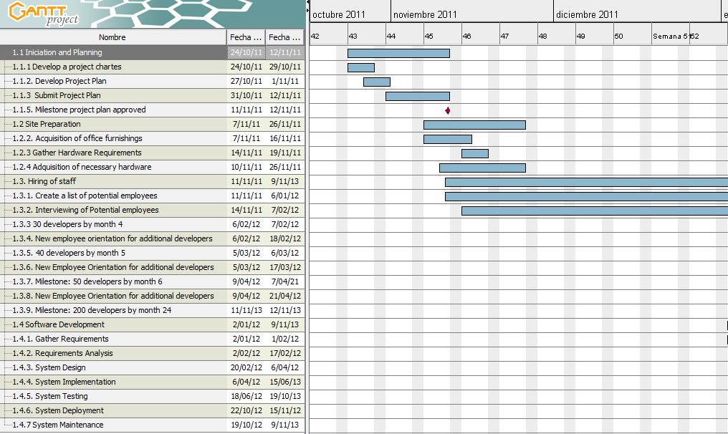

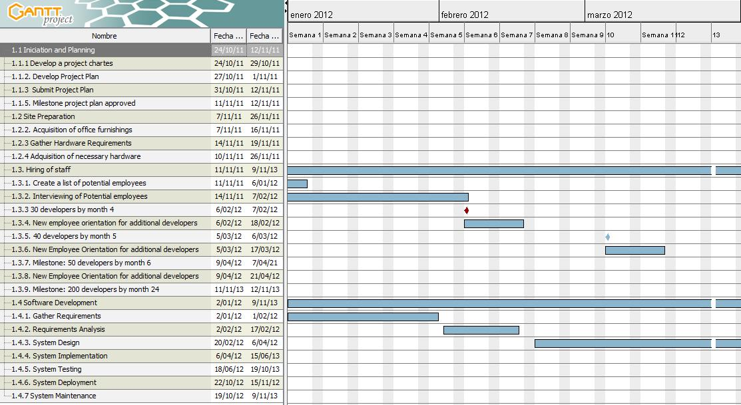

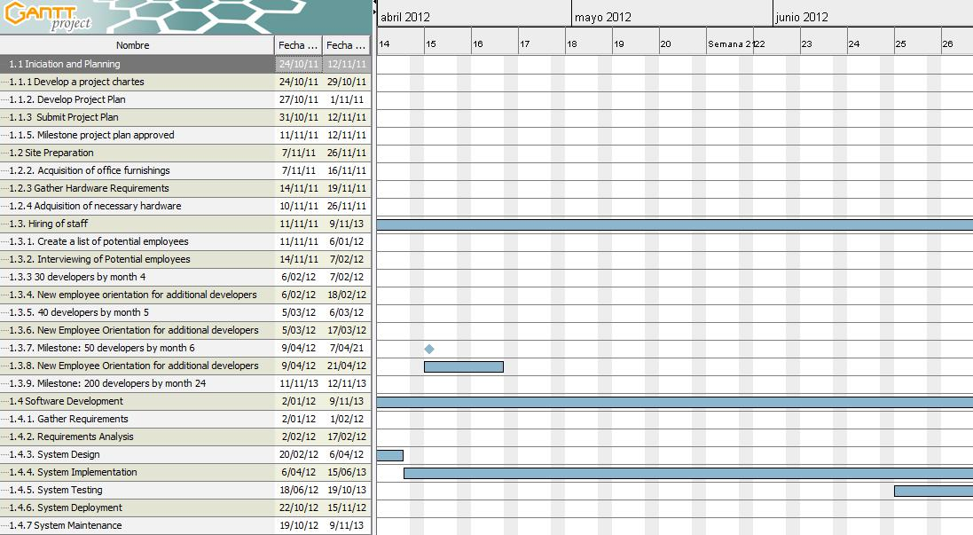

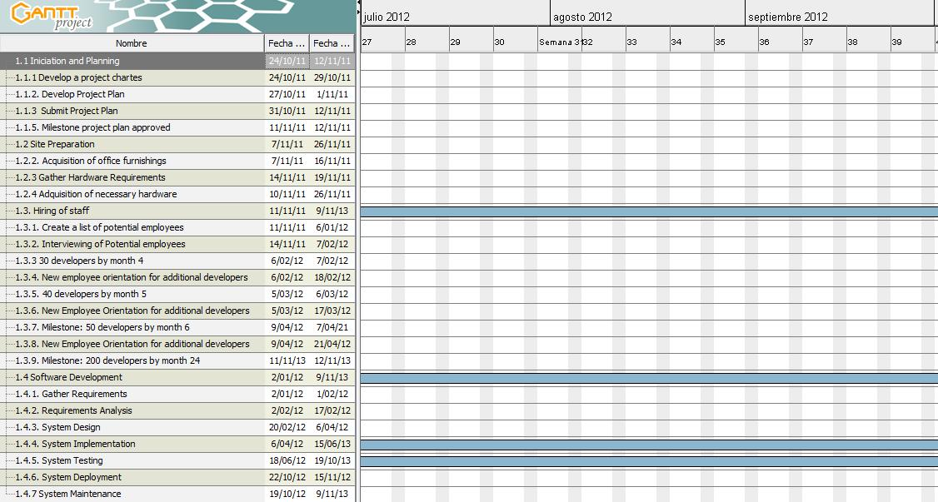

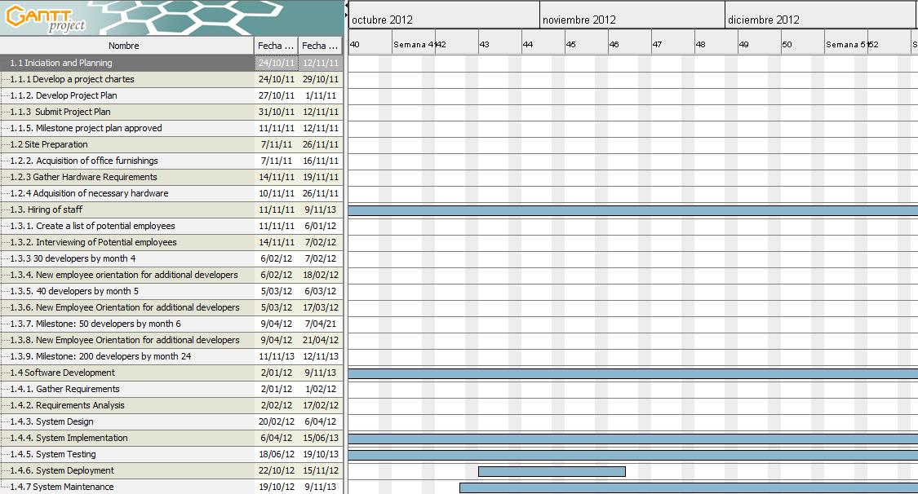

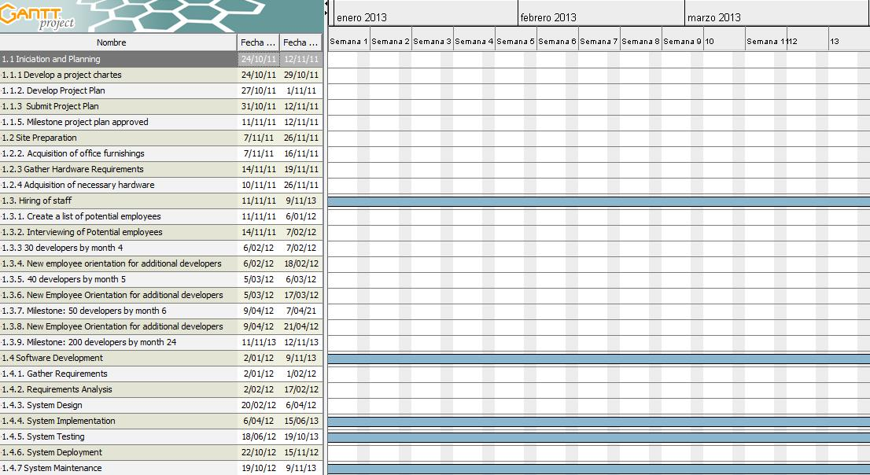

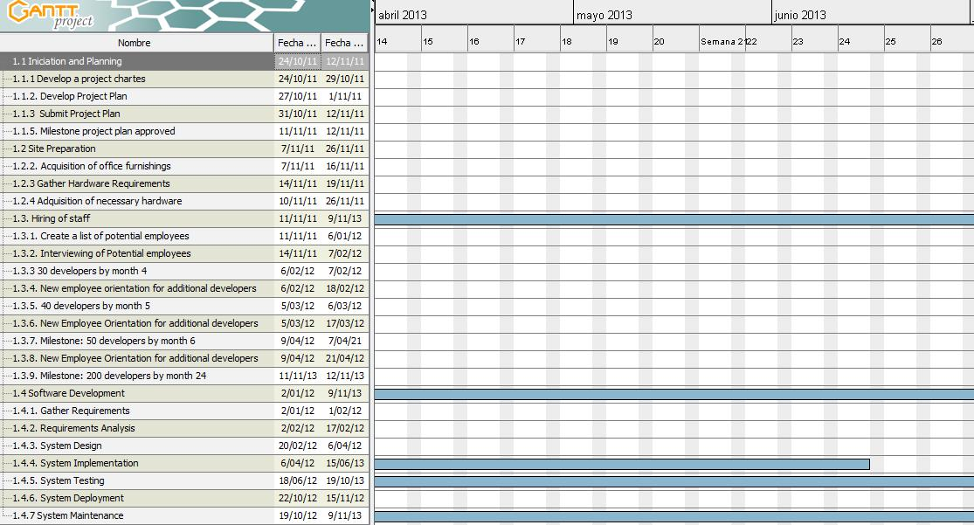

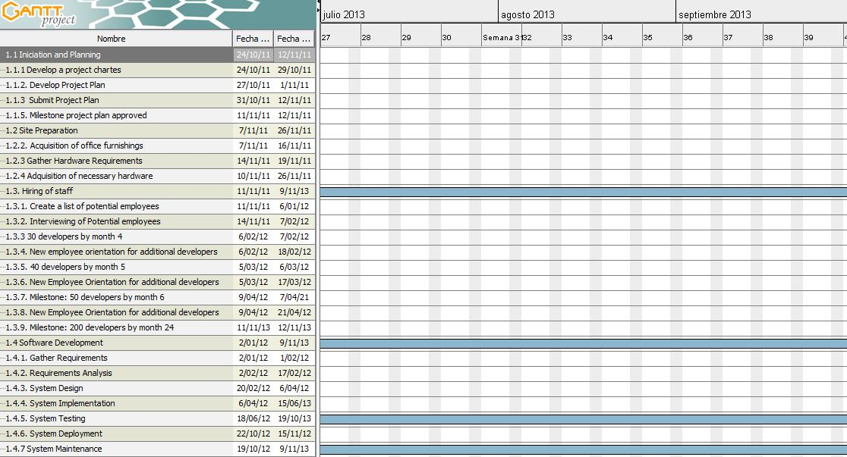

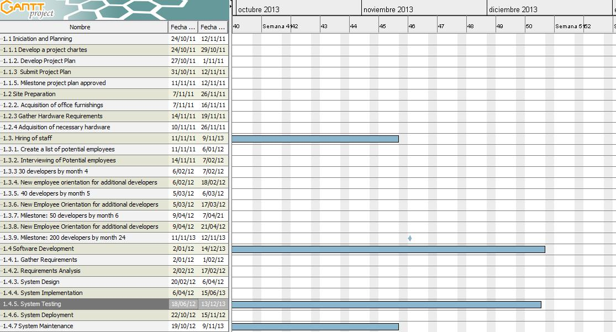

# The project cash flow or budget

## Introduction

Cash flow analysis is a method for determining the estimated annual costs and benefits for a project and the resulting annual cash flow. Cash flow analysis is used to determine net present value. Other important concepts include profits and profit margins, life cycle costing, sunk costs and learning curve theory. Estimating costs is, a very important part of project cost management. There are several types of cost estimate, including rough order of magnitude, budgetary and definitive. Each type of estimate is done during different stages of the project life cycle and each has a different level of accuracy.

**Total Project Duration:** 2 years and 16 days (aprox).

## Budget

|  |  |  |  |  |  |  |
| --- | --- | --- | --- | --- | --- | --- |
| **First Stage** |  | **Item** | **#units** | **unit price** | **value/month** | **total value (6m)** |
| 6 months | Professionals | Software developer | 50 | 1500 €/m | 75.000 | 450.000 |
|  |  | Use of Tech (talks) | 8 h/month | 50€/h | 400 | 2400 |
|  |  | Technical employees | 30 h/m | 20€/h | 600 | 3600 |
|  |  | QA testing | 30 h/m | 10€/h | 300 | 1800 |
|  |  | Change Control | 5h/m (if needed) | 20€/h | 100 | 600 |
|  | Materials & Equipment | Book of a specific technology | 10 | 20€/h | 200 | 200 |
|  |  | Workstations | 50 | 800 |  | 40.000 |
|  |  | Test Server | 2 | 500 |  | 1000 |
|  |  | Licenses (We will use tools of Open Source) | 0 | 0 | 0 | 0 |
|  |  | Software components:library GIS with source code | 1 | 10.000 |  | 10.000 |
|  | Total Cost I |  |  |  | 76.600 €/m | 509.600 €/6months |

|  |  |  |  |  |  |  |
| --- | --- | --- | --- | --- | --- | --- |
| **Second Stage** |  | **Item** | **#units** | **unit price** | **value/month** | **total value (6m)** |
| 6-12 months | Professionals | Software developer | 100 (50 now+50 before) | 1500 €/m | 150.000 | 900.000 |
|  |  | Use of Tech (talks) | 8 h/month | 50€/h | 400 | 2400 |
|  |  | Technical employees | 60 h/m | 20€/h | 1200 | 7200 |
|  |  | QA testing | 60 h/m | 10€/h | 600 | 3600 |
|  |  | Change Control | 10 h/m (if needed) | 20€/h | 200 | 1200 |
|  | Materials & Equipment | Book of a specific technology | 10 | 20€/h | 200 | 200 |
|  |  | Workstations | 50 | 800 |  | 40.000 |
|  |  | Test Server | 2 | 500 |  | 1000 |
|  |  | Licenses (We will use tools of Open Source) | 0 | 0 | 0 | 0 |
|  |  | Software components:library GIS with source code | 0 | 10.000 | 0 | 0 |
|  | Total Cost II |  |  |  | 152.600 €/m | 955.600€/6months |

|  |  |  |  |  |  |  |
| --- | --- | --- | --- | --- | --- | --- |
| **Third Stage** |  | **Item** | **#units** | **unit price** | **value/month** | **total value (6m)** |
| (12-18) months | Professional | Software developer | 150 (100 bef+50now) | 1500 €/m | 225.000 | 1.350.000 |
|  |  | Use of Tech (talks) | 8 h/month | 50€/h | 400 | 2400 |
|  |  | Technical employees | 80 h/m | 20€/h | 1600 | 9600 |
|  |  | QA testing | 100 h/m | 10€/h | 1000 | 6000 |
|  |  | Change Control | 15h/m (if needed) | 20€/h | 300 | 1800 |
|  | Materials & Equipment | Book of a specific technology | 10 | 20€/h | 200 | 200 |
|  |  | Workstations | 50 | 800 | 0 | 40.000 |
|  |  | Test Server | 2 | 500 | 0 | 1000 |
|  |  | Licenses (We will use tools of Open Source) | 0 | 0 | 0 | 0 |
|  |  | Software components:library GIS with source code | 0 | 10.000 | 0 | 0 |
|  | Total Cost III |  |  |  | 228.500 €/m | 1.411.000 €/6months |

|  |  |  |  |  |  |  |
| --- | --- | --- | --- | --- | --- | --- |
| **Last Stage** |  | **Item** | **#units** | **unit price** | **value/month** | **total value (6m)** |
| (18-24) months | Professional | Software developer | 200 (150 bef+50now) | 1500 €/m | 300.000 | 1.800.000 |
|  |  | Use of Tech (talks) | 8 h/month | 50€/h | 400 | 2400 |
|  |  | Technical employees | 80 h/m | 20€/h | 1600 | 9600 |
|  |  | QA testing | 120 h/m | 10€/h | 1200 | 7200 |
|  |  | Change Control | 20h/m (if needed) | 20€/h | 400 | 2400 |
|  | Materials & Equipment | Book of a specific technology | 10 | 20€/h | 200 | 200 |
|  |  | Workstations | 50 | 800 | 0 | 40.000 |
|  |  | Test Server | 2 | 500 | 0 | 1000 |
|  |  | Licenses (We will use tools of Open Source) | 0 | 0 | 0 | 0 |
|  |  | Software components:library GIS with source code | 0 | 10.000 | 0 | 0 |
|  | Total Cost IV |  |  |  | 303.800 €/m | 1.862.800 €/6months |

**Average Cost Per Month:** 190.375 €

**Total cost through 24 months:** 4.739.000 €

# Risk Log

## Introduction

As the product being delivered is unknown, there is a high level of risk associated with the project; chance is a significant element leading to risk of uncertainty of delivery. The purpose of this risk management plan

is to identify risks and develop strategies to help mitigate these risks.

## Risk Monitoring

During the ongoing meetings with the other project managers the main risks prevalent should be readdressed, discussed and the status of each risk readjusted. It is the responsibility of the project managers to provide these risk status updates, the trigger conditions and risk response

## Risk mitigation and avoidance

As more risks become apparent during the development these should be addressed immediately and discussed with the projects managers. These risks should be qualified by the project managers and avoidance and mitigation strategies should be developed with the team leads.

## Qualitative and quantitative

##### Risk likelihood rating

|  |  |  |  |  |
| --- | --- | --- | --- | --- |
| Low | Medium | High | Extreme | Not accessed |
| L | M | H | E | N |

##### Risk impact rating

|  |  |  |
| --- | --- | --- |
| **Grade** | **Mitigation strategy** | **Description** |
| N | No Action | No action required unless grading increases over time |
| A | Alternative action | Have alternative action plan |
| P | Produce Minimum | Mitigation plan to provide minimum accepted |
| I | Implemented Execution | Identified and avoided during execution |
| C | Catastrophic | Identified and avoided on commencement as a priority |

##### 

##### Combined likelihood / impact rating

|  |  |  |  |  |  |
| --- | --- | --- | --- | --- | --- |
|  |  |  | **Impact** |  |  |
|  |  | **Low** | **Medium** | **High** | **Extreme** |
|  | **Low** | N | N | A | C |
| **Likelihood** | **Medium** | A | P | I | C |
|  | **High** | I | I | C | C |
|  | **Extreme** | C | C | C | C |

##### Grade change assessment

|  |  |
| --- | --- |
| **Identifier** | **Description** |
| new | New risk |
| --- | No change |
| ↓ | Decreased risk |
| ↑ | Increased risk |

#### Risk register

|  |  |  |  |  |  |  |  |  |  |  |
| --- | --- | --- | --- | --- | --- | --- | --- | --- | --- | --- |
| **Id** | **Description** | **Project Impact** | **Likelihood** | **Impact** | **Combined** | **Grade change** | **Review date** | **Mitigation actions** | **Responsibility** | **Timeline** |
| 1 | Poor scope | Insufficient requirements | M | C | C | New | ongoing | iterative cycles | Project managers | Mid Q1 |
| 2 | Poor Project plan | Undeterministic deadlines | M | C | C | New | ongoing | iterative cycles | Project managers | Mid Q1 |
| 3 | Project plan rejected | delayed deadlines | C | C | C | New | ongoing | Develop alternatives strategies | Project managers | Mid Q1 |
| 4 | Site preparation delayed | delayed deadlines | C | C | C | New | ongoing | Adjust hiring quotas | Project managers | Mid Q1 |
| 5 | Workforce technical constraints | excessive training, delaying shipment / quality | M | M | P | New | ongoing | International hirements | Project managers | Ongoing |
| 6 | Poor requirements | Many change orders | M | M | P | New | ongoing | Identify minimum requirements/ design for extensibility | Team leads | Q1 |
| 7 | Poor Design | Poor software realization | L | H | A | New | ongoing | Extreme Programming | Designers | Q1 |
| 8 | Poor Implementation | Does not support change orders | L | H | A | New | ongoing | Scrum meetings to help realize extensibility | Programmers | Q2 |
| 9 | Poor testing | Many bugs | L | C | C | New | ongoing | Design test harnesses | Testers | Q1 |

# 

# Communications Plan

## Introduction

This communications plan presents the information pertinent to Investors, Project Managers, Managers and the other relevant parties during the process of the project. It outlines roughly how each party is responsible for administrating and delivering operational programmes, related to not with standing, strategies, relationships, the needs and expectations.

## Aims

The aim of this communication plan is to present an overview of the series of events or programmes as part of the MegaGlobalCorpSuperInc project management plan. This overview will highlight the roles and contributions of the parties involved and the time lines for deliveries therein.

## Target Audience

The targeted audience or stakeholders for the communications plan include the following

* Executives
* Sponsors
* Managers
* Project Managers
* Team employees

## Communications plan

#### Executives

|  |  |  |  |  |  |  |
| --- | --- | --- | --- | --- | --- | --- |
| **Activity** | **Stage** | **Finish Date** | **Medium** | **Responsibility** | **Audience** | **Frequency** |
| Project commencement | Understand | 1/2/2012 | Conference Call | Executive Project Manager | managers, employees | once |
| Announce Team lead | Understand | 3/2/2012 | Email | C.I.O | executives, managers, employees | once |
| Communicate company vision and how the project is going to contribute to this vision | Envision | 9/2/2012 | Internal Intranet /Email | Executive Committee | All managers and employees | once |
| Objectives and project goals kick-off meeting | Define and design | 10/2/2012 | Meeting | Project Managers | Project Team | Once |
| New Branch integration, training and goal realisation | Build and Deliver | 11/10/2012 | Conference calls | Executive team | Managers / Employees | Forth-nightly |
| Launch Feedback | Confirm | 1/2/2013 | Cooperative analyis, surveys | Project Managers | Managers, employees | Regulary |
| Announce improvements to be made | Optimize | 2/2/2013 | Conference call | Project Leader | Managers / Employees | If needed |

#### Managers

|  |  |  |  |  |  |  |
| --- | --- | --- | --- | --- | --- | --- |
| **Activity** | **Stage** | **Finish Date** | **Medium** | **Responsibility** | **Audience** | **Frequency** |
| Discuss Customer Relationship Management, Goals and timeline | Understand / Envision | Ongoing | Meeting | Manager | Employees | weekly |
| Review Process changes | Envision / Design | Ongoing | Meeting | Manager | Employees | as needed |
| One on One / Face to face meeting | Integration | Ongoing | Private meeting | Manager | Employee | monthly |
| Project updates / delivery Expectation | Define and Design | Ongoing | Email / Meeting | Manager | Employees | Regularly |
| Training | Integration / Build | Ongoing | Business trip / Conference call | Manager | Employees | once |
| Revise performance with each employee | Optimize | Ongoing | Meeting | Manager | Employees | Quarterly |
| Launch feedback and information dissemination | Confirm | 1/2/2013 | Intranet, Conference, meetings | Manager | All | Ongoing |
| Positive and negative progress | Optimization | Ongoing after launch | Team meetings | Manager | Employees | Weekly |
| Improvement plan | Optimize | 1/9/2012 ongoing | Email | Manager / Project manager | Employees | As it becomes available |

#### Employees

|  |  |  |  |  |  |  |
| --- | --- | --- | --- | --- | --- | --- |
| **Activity** | **Stage** | **Finish Date** | **Medium** | **Responsibility** | **Audience** | **Frequency** |
| Attend kick-off meeting | Define and design | 1/2/2012 | Meeting | Team Lead | Team | Once |
| Team representation during requirements gathering | Define / Design | 12/2/2012 | Meeting | Team Lead | Team | As scheduled |
| Disseminate Process Changes Information | Define and Design | Ongoing | Meeting | Team Lead | Team | As needed |
| Product validation feedback | Define and Deliver | Ongoing | Meeting | Team Lead | Team | weekly |
| Launch feedback | Confirm | 1/2/2013 ongoing | Meeting | Team Lead | Team | Regulary |

##### 

### 

# Quality Plan

## Introduction

Project quality management includes planning quality, performing quality assurance and performing quality control. Quality planning identifies which quality standards are relevant to the project and how to satisfy them. Quality assurance involves evaluating overall project performance to ensure that the project will satisfy the relevant quality standards. Quality control includes monitoring specific project results to ensure that they comply with quality standards and identifying ways to improve overall quality.

## Quality Plan

### Purpose

The purpose of this section is to provide a single point of reference on the topic of quality for project of MegaGlobalCorpSuperInc in Ireland.

### Scope

Quality Plan applies to project of MegaGlobalCorpSuperInc in Ireland developed by our company. This section describes issues related to quality assurance. Target audience of this section is as follows:

* Customer representatives;
* Quality Assurance group;
* Project Manager.

### Quality Objectives

The product must comply with all of the requirements described in Software Requirements Specification.Product’s conformity to Software Requirements Specification will be checked through passing the acceptance tests. Upon client's verification that all of the tests have been satisfactory passed, the product is considered to be of satisfactory quality. It means that product complies with all clients' requirements and is accepted by client.

### Management Organization

|  |  |
| --- | --- |
| **Role** | **Responsibility** |
| **Project Manager** | Allocate resources, set priorities, coordinate communication with the customer or user, he is responsible for keeping the team's focus is the main objective, to keep the project team to focus on the correct target. And establishes a set of practices to ensure the integrity and quality of project artifacts. |
| **System analyst** | Definition of system requirements, leads and coordinates use-case modeling. Outlines the system's functionality. |
| **Software architect** | Leads and coordinates technical activities throughout the project. Establishes the overall structure of product architecture: the overall structure of decomposition,Combination of elements, as well as the interface between these major groups |
| **Project technical assistant** | Responsible for the evaluation of project planning and project evaluation in the course of the project the main control point. |
| **Developer** | Responsible for developing and testing components, in accordance with the standards adopted by the integration project, to a larger subsystem. When test components, must be established to support the test, is also responsible for developing and testing the test components and corresponding subsystems. |
| **Test Designer** | Responsible for planning, design, implementation, and evaluation of tests, including:  1.Test plans and test model  2.Implementation of the test program  3.Evaluate test coverage, test results and test the validity  4.Generate test Assessment Summary |
| **Tester** | The Tester is responsible for test execution, Including test setup and test run, trial run and error recovery, defect records and test results recorded evaluation. |

### Tasks and Responsibilities

Guarantee the high quality of product the following actions must be done:

1. Project Review and Audit according to Review and Audit Plan. Responsibilities are described in corresponding section of this document.
2. Software Testing according to Test Plan. Responsibilities are described in corresponding section of this document.
3. Acceptance testing according to Acceptance Test Description. Responsibilities are described in corresponding section of this document.

### Metrics

To provide control over the development process and quality assurance the following metrics are used:

SLOC - Source Lines of Code

SCO - Software Change Orders

|  |  |  |
| --- | --- | --- |
| **Metric** | **Purpose** | **Sample measures/perspectives** |
| Progress | Iteration planning  Completeness | SLOC |
| Quality | Iteration planning  Rework indicator  Release criterion | Number of errors  Defect discovery rate  Defect density |
| Maturity | Test coverage for use | Test hours and type of failure |

**Metrics stand for:**

|  |  |
| --- | --- |
| Total SLOC | SLOCt = Total size of the code, source lines of code |
| SLOC under configuration control | SLOCc = Current baseline |
| Critical defects | SCO0 = number of type 0 SCO, Software Change Orders |
| Normal defects | SCO1 = number of type 1 SCO, Software Change Orders |

Review, Audit Plan and Problem Resolution

#### This section of the review including follow:

* Requirements Review---Software Specification Review,concerned with the software requirements specification .
* Architecture Review--- Design Review
* Code Review

#### Tools, Techniques, and Methodologies

##### Tools

* Bug tracker is used as a bug tracker for this project.
* Techniques
* Black Box Testing
* White Box Testing
* Methodologies
* Use RUP methodology create process given RUP, to ensure quality, RUP is Rational Unified Process,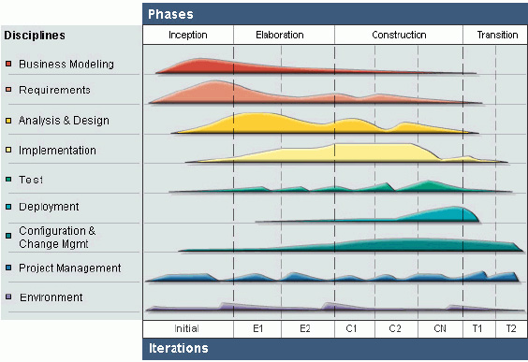

Figure 1. RUP

#### Controls

During the project implementation Source Control System is used.All project products like source code, report ,etc. are kept in the single Source Control System and the backup is by the person who is the appointed Implementer.

#### Quality Records

During the project implementation all defects are found are Recorded ,and a bug tracker is used as defect tracking system.

# 

# Project report

A project report of no more than one page. This report should outline how you expect the project to be governed and what structures and processes you have established in order to enable effective project control and governance.

### 

# Analysis and critique

A 1⁄2 page description of how the team worked. What did each person do in order to produce the portfolio?